Ancient Images

**Primary Audience**: 6th – 8th Grade

**Objective**: Students will be able to recognize some of the aspects of Egyptian art. Students will

understand why it is important for archaeologists to study art.

**Keywords:** Culture, art, frontalism

**Concepts**:

• Culture is the full range of learned behavior patterns that are acquired by people as members of a society. A culture is a complex, largely interconnected whole that consists of the knowledge, belief,

art, law, morals, customs, skills, and habits learned from parents and others in a society.

• Egyptian artists used a specific set of rules to create their art.

**Materials**:

Per Participant:

• Butcher block paper

• Pencil

• Ruler

• Paint

• Brushes

• Permanent black markers

**Pre-Activity Discussion**:

Introduce students to ancient Egyptian art.

• Using the photographs and images included with the educator’s guide, show examples of ancient Egyptian tomb art. Discuss key images.

• Discuss what the students see in the art and what they think the artwork is telling us about the

ancient Egyptian culture and belief system.

What can we learn by studying ancient Egyptian art?

• Using the stories and information provided on the artwork discuss what archaeologists have

come to understand about the ancient Egyptian culture from the artwork.

• Discuss why this is important information.

Discuss the rules ancient Egyptians used to create the art.

• Egyptian artists had to follow rigid rules about certain things. Most examples of Egyptian art

from any period strictly adhere to the same style. Egyptian artists followed a code, or a set of

rules, for producing the artwork. The style is called frontalism. In reliefs or paintings, frontalism

means that the head of the character is always drawn in profile.

• In almost all Egyptian wall paintings, a single eye faced out to the viewer. Egyptians painted body parts in the most easily and quickly recognizable position. Although the face is drawn in profile,

the eye is drawn from the front.

• The upper body is seen from the front. The legs are turned to the same side as the head, with

one foot placed in front of the other. Have students try to assume this position--face to the side,

shoulders to the front, hips and legs to the side. It is a position that is physically impossible to

assume.

• Every figure, in paintings or sculptures, stands or sits with a formal, stiff, and rigid posture. The

stance of the body is severe, but the faces are calm and serene, and usually tilted slightly towards

the sky, as if the figures were basking in the warm sun.

• In much Egyptian art, females were painted using an ocher (yellowish) color. Males were

depicted in a reddish brown hue.

• Most figures in Egyptian wall paintings who wear jewelry wear necklaces reflecting the society’s

worship of the sun. If taken off and laid flat, the beads and other decorations on these pieces

radiate out from the central hole like rays of the sun.

• The Egyptian artist had at his disposal only six colors--red, yellow, blue, green, black and white. These colors, made largely from mineral compounds, have retained their vibrancy over the millennia.

• Gods and pharaohs were portrayed larger than other people to convey their importance.

**Activities**:

1. Trace each student’s facial profile onto a large piece of white butcher paper.

• Be sure the silhouette has a neck.

• You may want to tape the butcher paper to the whiteboard and use the light from an overhead

projector.

• To minimize swaying, have the student lean one shoulder against the wall.

• Make sure that the profiles are not any larger than life-size.

• Trace the individual silhouettes while the students are working on another activity.

2. Demonstrate the project with a generic silhouette.

• Have students choose a point in the middle of their neck, below the chin. Put a dot at this

point. This is the central point from which the necklace radiates.

• Place the end of a sharpened pencil through a hole at the end of a ruler, then place the pencil

and ruler on the dot. Hold that pencil firmly in place, and put a second sharpened pencil

through the hole at the other end of the ruler. Move only the second pencil to create an arc on

the paper. This forms the bottom of the necklace.

• Keeping the first pencil in place, move the second pencil to a hole closer to the center dot.

Make a second arc. Repeat this procedure for all of the holes in the ruler to create up to four

bands on the necklace. Then use the ruler to draw a line at the front and back of the necklace.

• To divide the bands into sections, place dots equidistant around the circumference of the

outer circle--maybe 1/2 to 1 inch apart. Then connect each dot with the center point to create

radiating strands.

3. Have students draw the facial features.

• To draw the lips, draw a line in the center of the two bumps for the lips on the silhouette. Then

draw lines for the top and bottom lip.

• The eye goes in the “dent” where the forehead and nose meet, not up in the forehead. Both

Egyptian men and women wore eye makeup to protect their eyes from the harsh desert sun,

just as sports players wear black paint under their eyes today.

• Draw eyebrows and ears. The top of the ear is in line with the eye. The base of the ear is

generally at the line of the mouth opening.

• Draw the hair straight across above the eyebrow, and then down around the ear.

4. Have students choose an appropriate headdress and draw it on their silhouette.

• You can find some examples of headdresses attached to the educator guide.

5. Begin painting by filling in the skin tones on the face.

• Using the standard silhouette, demonstrate how to paint using an outline.

• Put a line of paint all the way around the outline of the space you are going to paint, including

around the outside of the eye and the eyebrow. Then fill in the rest of the space. The outline of

paint will help keep your paint inside the space you are painting.

6. After the skin tone has dried, use black to paint hair, outline of the eye, and eyebrow.

• Use the same outlining technique you used for the skin tones.

7. After the black paint has dried, paint the necklace using yellow, red, blue, green, & white.

• Metallic gold paint may be used in a few spaces as an accent.

• Each band of the necklace should be painted in a pattern, not random colors. Use the outlining

technique to keep the colors separate. Have the students decide on the pattern they will use

before they begin painting.

8. After the necklace has dried, paint the headdress using yellow, blue, red, green, & white.

• Metallic gold paint may be used in a few spaces as an accent.

• Use the outlining technique to keep the colors separate.

• Also, paint the white part of the eye.

9. When all of the paint has dried, use black permanent markers to outline each color.

Possible Interactive Questions:

• How do we use art to express current cultural happenings?

**Further Exploration**:

• Using the self-portrait as a model, create a mask. Use plastic face forms and add papier-mache or plaster gauze strips over the top. Add the nose, mouth, and headdress details with newspaper and aluminum foil rolled and taped onto the jug. See http://www.princetonol.com/groups/iad/lessons/middle/Larrymask.htm

for more information. When the papier-mâché is dry, ask students to paint the mask using

gold metallic paint, or brown, ochre, black, white and blue.

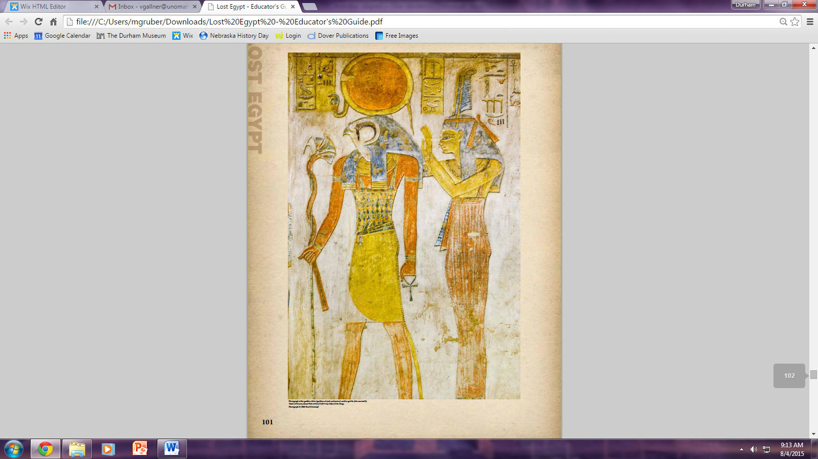

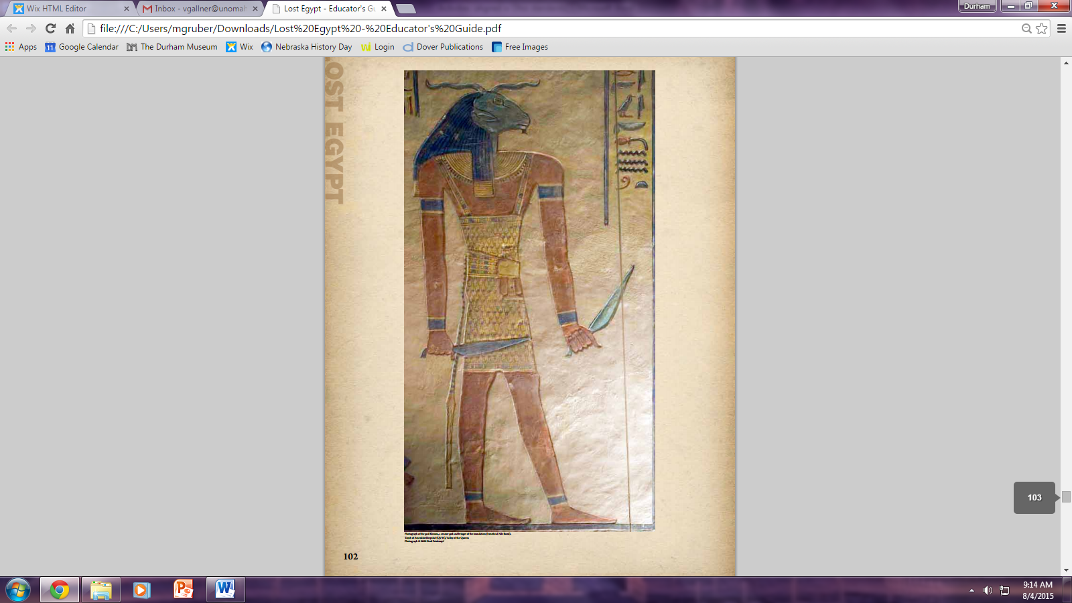

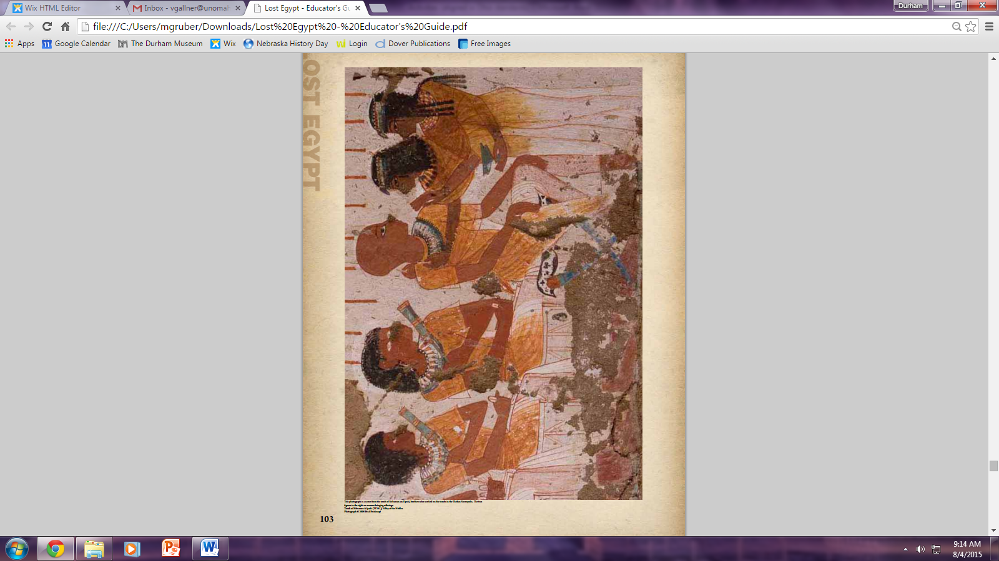

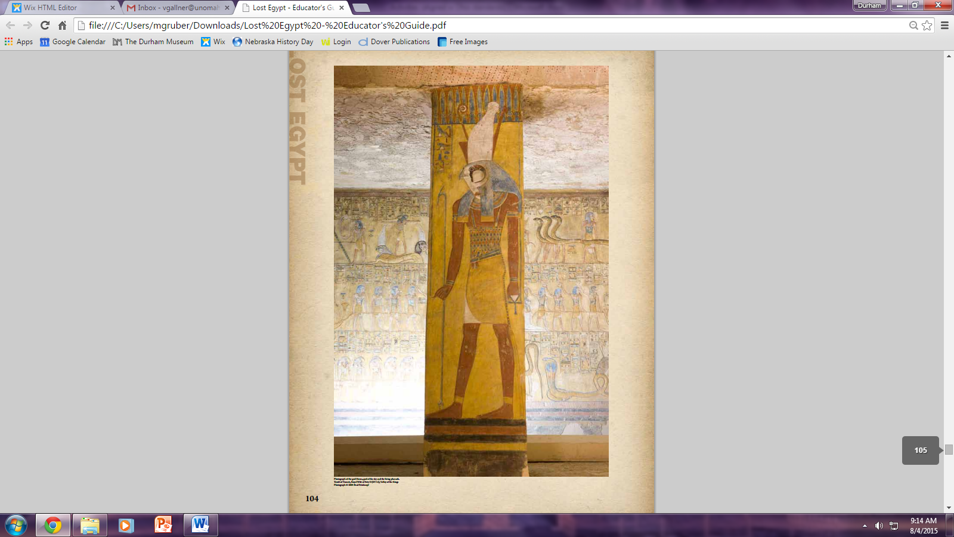

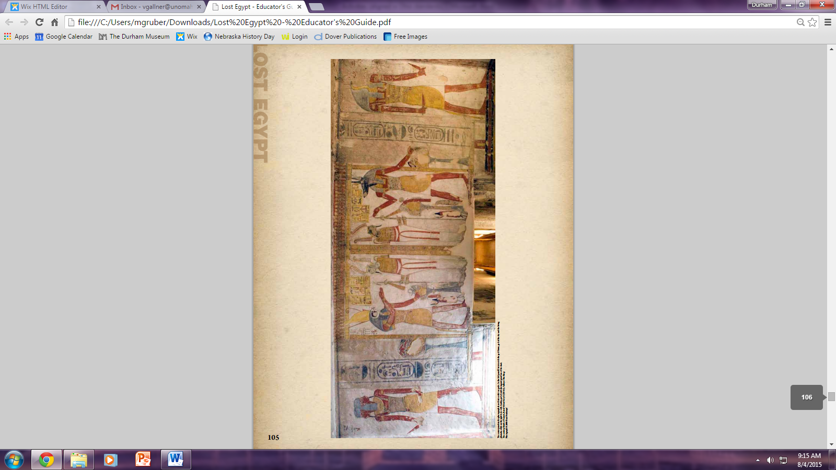

*Nebraska Academic Content Standards:*

*Social Studies:*

* *SS 8.4.2.a (WLD) Analyze the impact of people, events, ideas, and symbols, including various cultures and ethnic groups, on history throughout the world by era (e.g., Early Societies and Civilizations: culture prior to urbanization, Chavin, Toltecs, River Valley Civilizations and the development of agriculture, Songhai, Mali, Mesoamerica, Gupta Empire; Ancient and Classical Empires and Major Religions: Chinese and Japanese Dynasties, Greco-Roman Empires, Incas, Mayas, Aztecs, Hinduism, Taoism, Buddhism, Judaism, Christianity, Islam; Expanding Zones of Exchange and Encounter: Silk Road (World Studies might also include: Ancient Civilizations of the Americas, Europe, Asia, and Africa)*
* *SS 8.4.2.b (WLD) Analyze how global civilizations have changed over the course of time, using maps, documents, and other artifacts.*
* *SS 3.3.4.b Compare and contrast the spread and diffusion of cultural traits (e.g., spread of ideas, languages, religions, people, goods, customs, traditions)*
* *SS 8.3.4.c Analyze and explain components and diffusion of cultures (e.g., religion-spread of various belief systems, popular culture, spread of fast food chains, language-spread of English, technology-adoption of agricultural advancements, railroads, people as carriers and physical and cultural barriers, expansion and relocation, hierarchical-expansion diffusion of fashion from Paris and London to Nebraska communities)*
* *SS 3.4.2.a Describe the role of historical people, events, ideas, and symbols, including various cultures and ethnic groups (e.g., local cultural figures, landmarks, celebrations, and cultural events)*
* *SS 8.4.2.a (WLD) Analyze the impact of people, events, ideas, and symbols, including various cultures and ethnic groups, on history throughout the world by era (e.g., Early Societies and Civilizations: culture prior to urbanization, Chavin, Toltecs, River Valley Civilizations and the development of agriculture, Songhai, Mali, Mesoamerica, Gupta Empire; Ancient and Classical Empires and Major Religions: Chinese and Japanese Dynasties, Greco-Roman Empires, Incas, Mayas, Aztecs, Hinduism, Taoism, Buddhism, Judaism, Christianity, Islam; Expanding Zones of Exchange and Encounter: Silk Road (World Studies might also include: Ancient Civilizations of the Americas, Europe, Asia, and Africa)*

*Fine Arts Standards*

* *FA 5.2.1.a Develop ideas using a variety of materials.*
* *FA 5.2.1.b Use observation, imagination and interpretation in creating artworks that reflect a variety of styles, themes, and subjects.*
* *FA 5.2.1.d Identify and use elements of art and principles of design to brainstorm visual possibilities (e.g., create symmetrical and asymmetrical balance using line and shape).*
* *FA 5.2.1.e Apply various techniques to develop craftsmanship (glossary) skills (e.g., use cutting and gluing techniques to produce clean edges without visible glue).*
* *FA 5.2.4.b Compare and contrast works of art from a variety of contemporary, historical, and cultural contexts.*
* *FA 5.2.4.c Identify and discuss purpose and function of different art forms (e.g., “is this object a sculpture, bowl, or decoration?”).*
* *FA 5.2.4.d Explore how images and objects are used to convey a story, familiar experience, or connection to the world.*

*Common Core Standards:*

* *CCSS.ELA-LITERACY.RH.6-8.1 Cite specific textual evidence to support analysis of primary and secondary sources.*
* *CCSS.ELA-LITERACY.RH.6-8.2 Determine the central ideas or information of a primary or secondary source; provide an accurate summary of the source distinct from prior knowledge or opinions.*
* *CCSS.ELA-LITERACY.RH.6-8.7 Integrate visual information (e.g., in charts, graphs, photographs, videos, or maps) with other information in print and digital texts.*